Ideation Phase
Define the Problem Statements

Date | 1 march 2026
Team ID | FYBtech62
Project Name | AI-Based Anomaly Detection
Maximum Marks | 2 Marks

Customer Problem Statement Template:
Create a problem statement to understand your customer's point of view. The Customer Problem Statement template helps you focus on what matters to create experiences people will love.
Problem  Statement (PS) | I am  (Customer) | I’m trying to | But | Because | Which makes me feel
PS-1 | I am a hospital administrator / doctor | I’m trying to monitor patient vital signs in real time | But it is difficult to identify abnormal patterns quickly | Because patient data is large and continuously generated | Which makes me feel worried about missing critical health alerts
PS-2 | I am a system operator / healthcare analyst | I’m trying to detect unusual behavior in patient health data | But manual monitoring is slow and error-prone | Because humans cannot analyze large datasets instantly | Which makes me feel the need for an automated AI-based anomaly detection system
A well-articulated customer problem statement allows you and your team to find the ideal solution for the challenges your customers face. Throughout the process, you’ll also be able to empathize with your customers, which helps you better understand how they perceive your product or service.
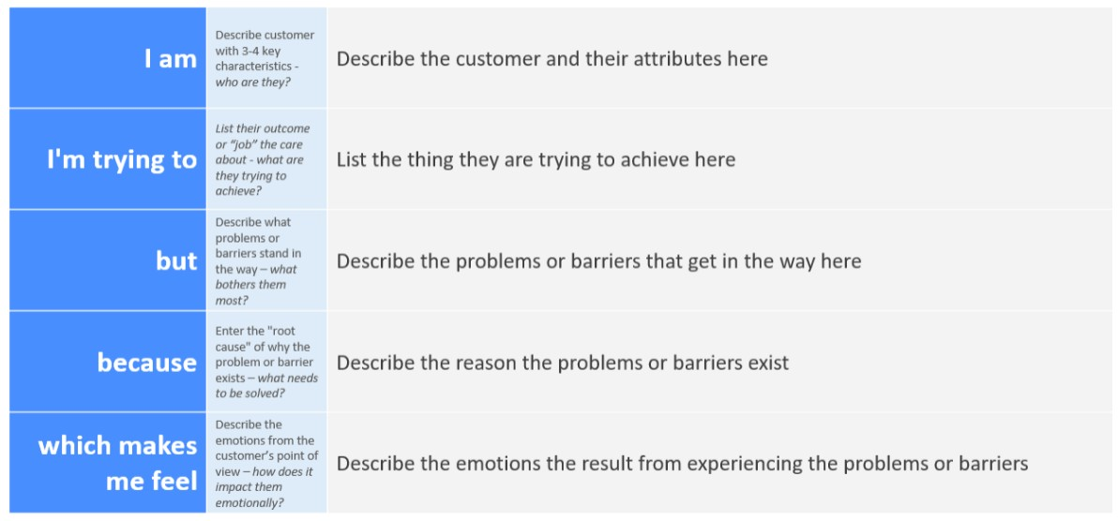
Reference: https://miro.com/templates/customer-problem-statement/ Example:
